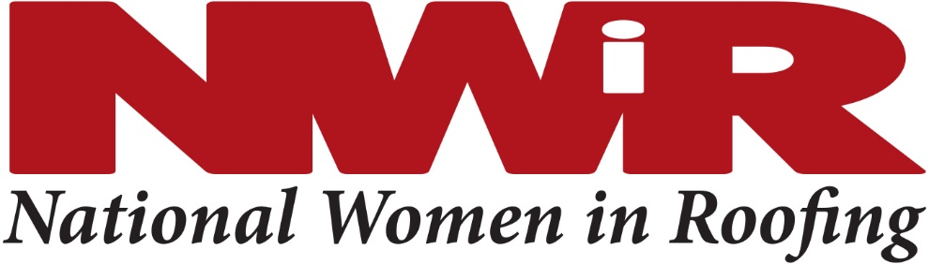
Councils Committee
October 12, 2017 at 11am EDT
Webinar & Conference Call

Agenda

- Quick Intros
- Event recaps:
  - Quick recaps from Councils who have held events
    - South Florida: has had first organizing meeting; next event coming up in conjunction with local roofing contractor association
    - South Texas: has had their first conference call, has a very diverse board, and will be having a gathering next month
    - New Mexico: has had a couple Networking events and a community service event
    - Georgia: had 26 members at recent meeting, 11 sponsors, promoted IRE participation, has full slate of board members in several different positions; committees submit ideas for events to officers and they use that to build out their calendar; had education presentation from a local workforce development group that recruits workers into the construction industry and mentors young people entering that field as well
    - New Jersey: clothing drive and meeting at a secondhand boutique
    - Carolinas: education coming up, conference call today
    - Dallas-Fort Worth: 16 at recent meeting
    - Colorado: meeting next week with Mastermind group; CRA tradeshow in January; issue with uninvited guests
    - Oregon: had a meeting this past week, community service project for Christmas with local school; Kendall has featured in Professional Roofing; women’s build for HH and a homeless shelter next year; heard that Washington State also wants to start Council
  - Updates from Councils with upcoming events
  - Updates from other Councils just getting started
- Growing Council membership
  - MEMBERSHIP VERIFICATION: to verify membership, email Julie Massaro (NWIR Member Services Coordinator) at info@nationalwomeninroofing.com
  - Collaborate with local roofing contractor association and ask them to help promote your events
  - Having a hard time getting people to commit to being on the board – it’s okay to have committees without board members
- Website Update
- Collateral Needs
  - South Florida
  - Carolinas
  - Southern California – palm cards and trifolds
- Update on NWIR Day
- Communications Update
  - Photos, meeting Notices, and meeting recaps to Renae for newsletter
  - Notices to Ellen for database mailing (Council forming and major events)
  - Pictures email to info@nationalwomeninroofing.com

NEXT MEETINGS:

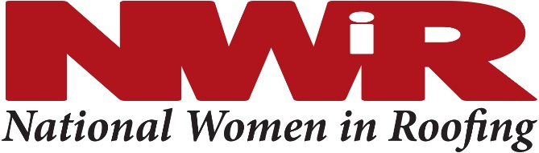

Preparations are underway for our first NWIR Day! This will take place Sunday February 4 in conjunction with IRE at the New Orleans Convention Center.
Please let us know if you will be attending and if you are willing to volunteer your time during the event. Thank you to all those who have signed up thus far.
We are looking for facilitators for discussion groups, people to assist at registration and a few general set up volunteers.

Facilitators: 45 min discussions – 2 facilitators at each. Each topic held twice that day. This will not require upfront work since we are focusing these discussions on engagement, getting the attendees involved and facilitators being there as subject matter experts and to kickoff and lead the discussions.

1) Building your network of professional allies; networking for success
2) Leveraging Social Media as a means to success
3) Providing Organizational and Personal Support to the next generation of women leaders
How to be a good mentor/mentee
4) Your Brand: how to sell yourself, setting yourself apart, building your value
Write better emails, “be different, be better”

The following topics already have designated facilitators:
5) Employee Development; recruit, attract talent, retention
Get women involved – how to reach out, offer roofing as career choice.
How diversity helps business
6) Work/life balance -
Stress/emotion/passion. Family/childcare solutions – stories how others handle?
7) Make your voice heard in a male dominated field – challenges we face, strategies to overcome them.
Tell your own story – success in roofing.

If there are other topics that you feel would be relevant to the audience and you are comfortable discussing, we would love to hear them.

Thank you.

Contact Lisa Lambrix and Tara Gerhardt to volunteer!
Lambrix, Lisa llambrix@gaf.com
Tara Gerhardt tgerhard@duro-last.com

