TAMPA BAY CHAPTER

April Membership Meeting Round Table on Career Progression-Diana King

Please join us at Tequilas Ybor 1613 E 7th Ave, Tampa at 5:30pm April 19th for our meeting and painting social (7pm)

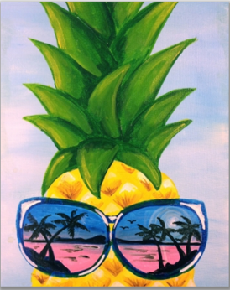

https://www.paintnite.com/events/pineapple-reflection-at-tequilas-ybor-10035984

Use coupon code FOREVER40 to receive discount ($27 with discount). Please note you need to sign up in advance. Sign up now for discount, space is limited.

RSVP to: NWIRFL@gmail.com or Dawn@deltarepgroup.com 727-420-3112
BECOME A MEMBER!
http://nationalwomeninroofing.org/membership/become-a-member/

