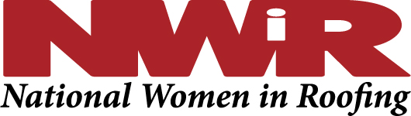
Frequently Asked Questions for the Board of Directors
March 2020

Please print this for handy reference but
also save to your desktop so that the links are easily accessible for you.

- Can I use a member logo on my email? Yes! Go here https://nationalwomeninroofing.org/membership/membership-benefits/
- How do I get in touch with the __________________ Council (chapter)? https://nationalwomeninroofing.org/councils/
- Is there a Council/chapter in my area? https://nationalwomeninroofing.org/councils/
- I’m interested in being a member. Can you give me more information? https://nationalwomeninroofing.org/membership/
- Can you add my email to the contact list for a particular Council? You can do this yourself by updating your profile.
- I’m a Council leader and can’t find a particular document. 99% of things you’ll need are on the Resources for Council Leaders page. You can get the password by looking at a previous agenda or by calling the office.
- I’m a sponsor and want access to a logo. Yes! Go here https://nationalwomeninroofing.org/sponsorship/resources-for-sponsors/ password is nwirsponsorsinc2016
- I’m a sponsor and want to submit information to the newsletter or to a blog. Yes! Go here https://nationalwomeninroofing.org/sponsorship/resources-for-sponsors/ password is nwirsponsorsinc2016

The front line in the NWIR office can also help you with the following questions; call the office at 303-450-3150
- What is my member number?
- I can’t get into the member database, can you please reset my password?
- I need to change my username.
- I need to change my email.
- I want to access a password protected page, how do I find out the password?
- I’m a Council leader and can’t get into the website to access my Council page to update it.

Almost everything else you should need should be on the Resources for the BOD page, password is nwirbodinc2016

